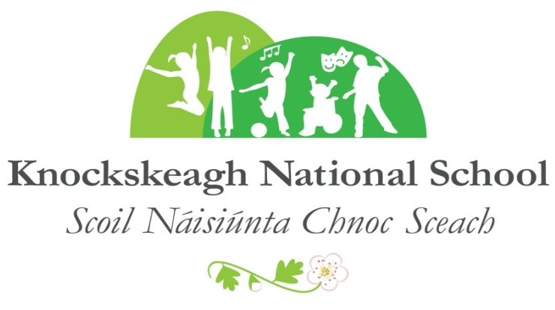
ANNUAL ADMISSION NOTICE
in respect of admissions to the 2027/2028 school year
Admission Policy and Application Form
A copy of the school’s Admission Policy and the Application Form for Admissionfor the 2027/2028 is available as follows:–
To download at: www.knockskeaghns.ie
On request: by emailingcnocsceachns@gmail.com or writing to: Knockskeagh National School, Clonakilty, Co. Cork P85AV90

PART 1 - Admissions to the 2027/2028 school year

Application and Decision Dates for admission to 2027/2028
The following are the dates applicable for admission to Junior Infants:

The school will commence accepting applications for admission on | 1st October
The school shall cease accepting applications for admission on | 26th February
The date by which applicants will be notified of the decision on their application is | 12th March
The period within which applicants must confirm acceptance of an offer of admission is | 19th March

*Failure to accept an offer within the prescribed period above may result in the offer being withdrawn
Note: the school will consider and issue decisions on late applications in accordance with the school’s admission policy.

Special Class Application and Decision Dates for admission to 2027/2028
The following are the dates applicable for admission to the school’s Special Class which caters for children with Autism or Multiple Disabilities:
The school will commence accepting applications for admission to the special class on | 1st October
The school shall cease accepting applications for admission to the special class on | 1stFebruary
The date by which applicants will be notified of the decision on their application for admission to the special class is | 12th March
The period within which applicants must confirm acceptance of an offer of admission is | 19th March

*Failure to accept an offer within the prescribed period above may result in the offer being withdrawn

Number of places being made available in 2027/2028

The number of places being made available in junior infants is | 30
The number of residential places is (boarding schools only) | n/a
The number of non-residential places is (boarding schools only) | n/a
The number of places being made available in the special classes catering for children with specific needs is:  4 ASD Classes  Multiple Disabilities Class | 2  3

