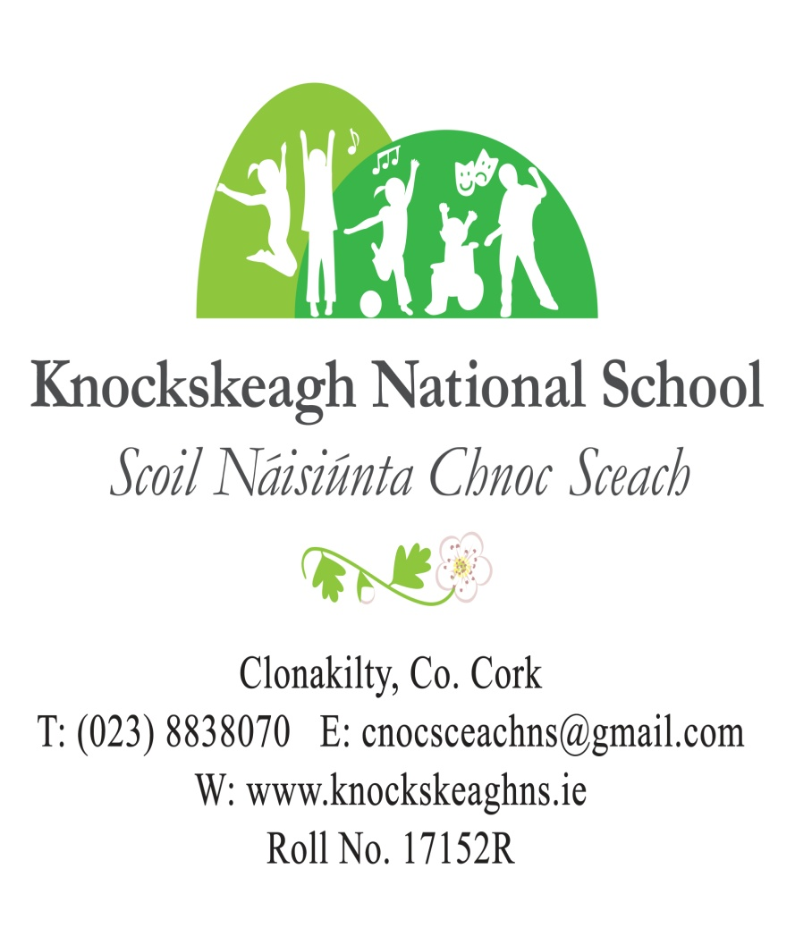

**ANNUAL ADMISSION NOTICE**

**in respect of admissions to the 2026/2027school year**

**Admission Policy and Application Form**

A copy of the school’s **Admission Policy** and the **Application Form for Admission** for the 2026/2027is available as follows: –

To download at: [www.knockskeagh](http://www.knockskeagh)ns.ie

On request: by emailing [cnocsceachns@gmail.com](mailto:cnocsceachns@gmail.com) or writing to: Knockskeagh National School, Clonakilty, Co. Cork P85AV90

**PART 1 - Admissions to the** **2026/2027 school year**

**Application and Decision Dates for admission to 2026/2027**

The following are the dates applicable for admission to Junior Infants:

|  |  |
| --- | --- |
| The school will commence accepting applications for admission on | **1st October** |
| The school shall cease accepting applications for admission on | **28th February** |
| The date by which applicants will be notified of the decision on their application is | **13th March** |
| The period within which applicants must confirm acceptance of an offer of admission is | **20th March** |

**\*Failure to accept an offer within the prescribed period above may result in the offer being withdrawn**

**Note: the school will consider and issue decisions on late applications in accordance with the school’s admission policy.**

**Special Class Application and Decision Dates for admission to 2026/2027**

The following are the dates applicable for admission to the school’s Special Class which caters for children with Autism or Multiple Disabilities:

|  |  |
| --- | --- |
| The school will commence accepting applications for admission to the special class on | **1st October** |
| The school shall cease accepting applications for admission to the special class on | **1st February** |
| The date by which applicants will be notified of the decision on their application for admission to the special class is | **13th March** |
| The period within which applicants must confirm acceptance of an offer of admission is | **20th March** |

**\*Failure to accept an offer within the prescribed period above may result in the offer being withdrawn**

**Number of places being made available in 2026/2027**

|  |  |
| --- | --- |
| The number of places being made available in junior infants is | **30** |
| The number of residential places is (boarding schools only) | **n/a** |
| The number of non-residential places is (boarding schools only) | **n/a** |
| The number of places being made available in the special classes catering for children with specific needs is:  4 ASD Classes  Multiple Disabilities Class | **8**  **2** |