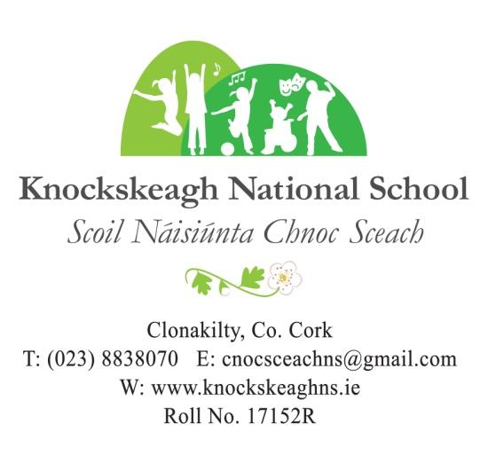

**NEWSLETTER        WEEK 8 (16.10.24)**

**Information for Parents & Guardians**

Attached please find our up-dated School Information Document.

**Be Safe! Be Seen!**

Over the next two years, our Green-Schools Committee will be working towards trying to get our 9th Green Flag. The theme for this flag is *Global Citizenship – Travel*. The ultimate aim of this theme is to continue our work on encouraging walking, cycling, scooting, using public transport or carpooling. Whilst it is very difficult for us to promote walking and cycling to school on our busy roads, we can encourage carpooling and promote safe walking, safe cycling and safe road use in the evenings and at weekends in our everyday lives. This theme also allows us to discover how we can have a positive impact on global issues such as air quality and sustainable development and over the coming two years, we will focus on trying to reduce our carbon footprint.

In order to promote safety on our roads and encourage walking, scooting and cycling (not just in school, but also at home in the evenings), all children will receive a high visibility vest or armband today. As a school, road safety was discussed and we called today ‘***WOW Day’*** (*Walk on Wednesday*) and we are encouraging everyone to get out for a walk at some stage. All classes participated in a walk around the school today at times that suited them. Please keep the high visibility attire that is sent home today at home so you can make the most out of it in order to stay safe on the roads!

**Dare to Believe Olympian Visit**

We were delighted to hear recently that our application for a Dare to Believe Olympian Ambassador visit was successful. The application process included entries from hundreds of primary and secondary schools all over the country and the Dare to Believe Team were impressed by our school’s commitment to promoting sport for our health and wellbeing.

We will be paid a visit by West Cork sprinter ***Phil Healy***. Phil was part of the fantastic women's relay team that placed fourth in the Paris Olympic Games last Summer. We are honoured to welcome such an inspiring athlete to our school this December.

**Swimming Lessons**

Swimming for children in **5th Class** began today. The classes will run for **6 weeks** and the cost per pupil is €60. As was already stated, you may if you wish enclose payment at this time. However, if this is not convenient, payment can be made at any stage during the course of the lessons.

**Mid-Term Break**

The school will close for Mid-Term Break on Friday 25th October (**full school day**) and will re-open on Monday 4th November. Normal school-day times apply.

**End-of-Year Bills**

It would be greatly appreciated if any money still outstanding from last year’s end-of-year bills could be paid before mid-term break, please!

*‘Celebrating Difference Celebrating Learning Celebrating Children’*

**Halloween**

On **Friday, 25th October**, we will hold our Annual ‘**Game Playing Day’**. As this is the day we break for mid-term, we are planning on making this a fun day with lots of activities for everyone. All children are invited to bring in a game of their choice to play with friends.

We will also hold our **‘Annual Halloween Fancy Dress Parade’** around the track(weather permitting). Children are invited to dress in *Halloween Costume* for the day with prizes being awarded to the children with the best costumes made from ***recycled* materials**.

**Camogie**

Tomorrow, Thursday, 17th October, our camogie team will participate in a tournament in Ahamilla, Clonakilty GAA grounds, as part of this year's West Cork Camogie Competition.  The games will commence at 10:30 a.m. and staff members will transport our team to and from the venue during the morning.  We wish the team the very best of luck.

**Hurling**

Our 4th, 5th & 6th class hurlers played the West Cork Hurling Competition in beautiful sunshine at Clonakilty GAA grounds last Thursday. Our boys displayed a great spirit and attitude throughout the games. They can be very proud of both displays against Barryroe N.S. and Bantry Boys N.S. Thank you to all organisers of this recently formed hurling competition as it's a fantastic way to introduce young players to the game of hurling. Some of our pupils played hurling for the first time this year. Well done boys!

**Jersey Day in Knockskeagh**

We joined GOAL to celebrate Jersey Day last Friday. Well done to all our pupils and staff for getting in the spirit and helping to raise vital funds to be used in vulnerable communities worldwide.  A fantastic total of €346 was raised during the day. Thank you to all who contributed to this worthy cause #GOALJerseyDay

**Good News**

Well done to Sive O'Sullivan (2nd Class), Edei O'Donovan, Laoibhse O'Hara (3rd Class),

Maia O'Sullivan, Eoin Rice (4th Class), Charlie Baker (5th Class), Laoise Ryan & Lucy O'Regan (6th Class) who all competed in the Cross-Country event that was held in West Muskerry over the weekend. All represented the local Clonakilty Athletics Club.

Focus for this Week

Visual Arts – Drawing

P.E. – Games & Dance

Fundamental Movement – Walking/Running

Literacy – Recount

Mental Maths – Counting back & forwards

I.T. – Typing

S.P.H.E. – Relating to Others/Self Identity & RESPECT

Drama – Still Image

Gaeilge – Mé Féin

Music – Pulse

Thought of the Week

Too much of a good thing can be wonderful!