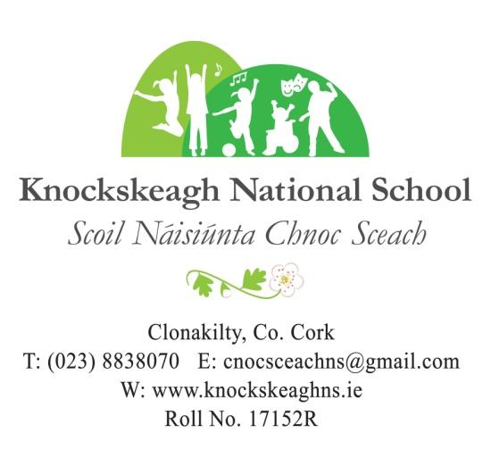

**NEWSLETTER        WEEK 16 (11.1.23)**

**Welcome Back**

As we start a new year, we, the staff, would like to extend a very warm welcome back to everyone. We would like to wish you and your families a very happy 2023 and every good health for the forthcoming year.

THURSDAY

9TH FEBRUARY, 2023

11.00 a.m. – 1.30 p.m.

PHONE: 023 8838070

EMAIL: cnocsceachns@gmail.com

ENROLMENT/OPEN DAY

After-School

Club

Breakfast

Club

[WWW.KNOCKSKEAGHNS.IE](http://WWW.KNOCKSKEAGHNS.IE)

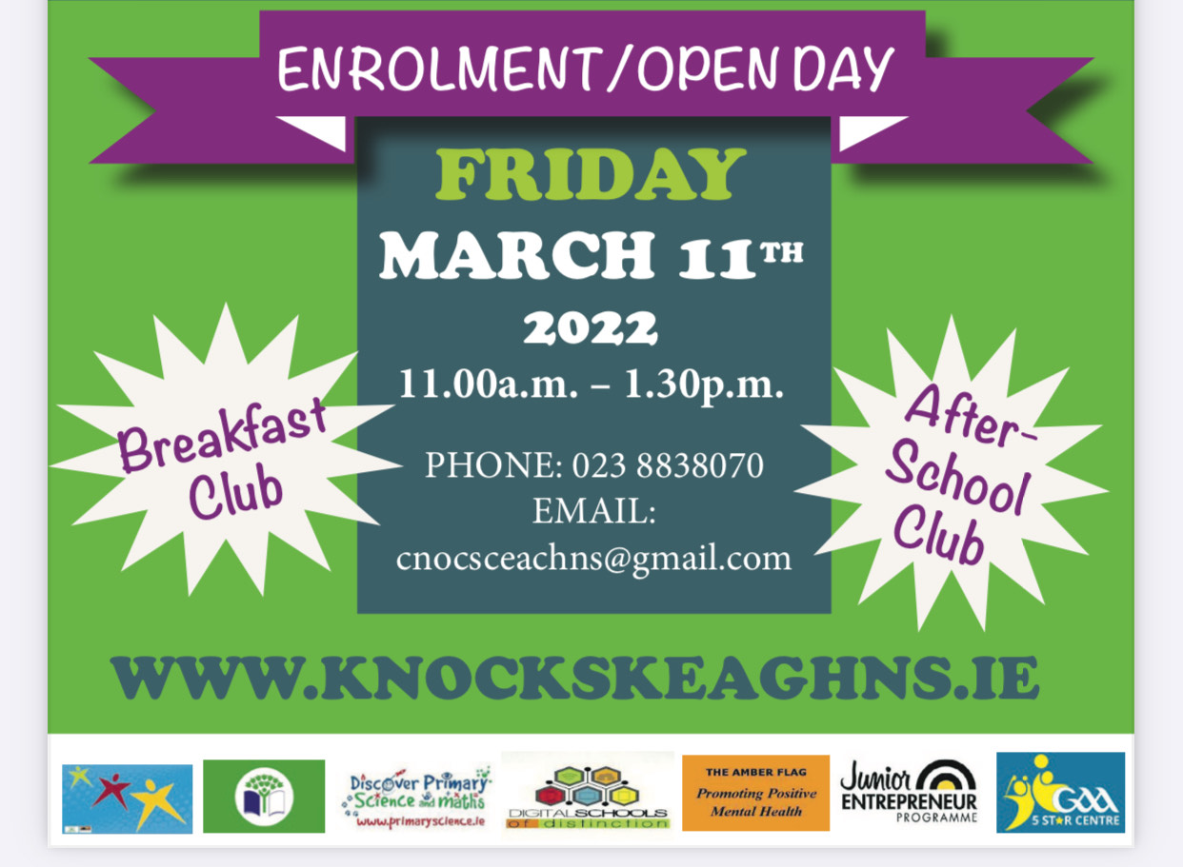

**Weather Alert Notice**

As we face into a period of possible inclement weather conditions. We ask everyone to exercise caution on the roads. If occasions arise when the school will not open, all parents will be **notified by text**. Please be advised that in the absence of such a notification, the school will open, but it is up to the discretion of all parents to travel **only if they feel it is safe to do so**. In such circumstances, arriving late or not at all is perfectly acceptable. Be safe on the roads.

**St. Vincent de Paul Food Collection**

Our local St. Vincent de Paul organisation contacted the school to express their gratitude for the very kind food donation before Christmas. Thank you for your continued support.

*‘Celebrating Difference Celebrating Learning Celebrating Children’*

**Gymnastics**

We were delighted to secure the services of gymnastics coach Aoife McAuley for the coming weeks in Knockskeagh. Aoife will coach a gymnastics class each Monday for 3rd, 4th, 5th and 6th class for the next four weeks. After this block, it will be the turn of Junior Infants to 2nd Class on Mondays for four weeks. Our first sessions last Monday were very enjoyable and our pupils loved the high level of gymnastics on offer. We look forward to the gymnastics classes in the coming weeks and we thank Aoife for providing fun and challenging classes in a safe way.

**Camogie Blitz**

Our 4th class girls will travel to Ballinacarriga next Friday, to take part in a non-competitive indoor camogie blitz. The girls will travel by bus and will be back in school before normal closing time. 4th class boys will have a similar hurling blitz on Friday 20th January.

**Aldi Promotion for Schools**

Aldi is again giving one primary school a chance of winning prize money of €50,000 to be used for sports facilities for the school, and ten primary schools are in with a chance of winning prize money of €5,000.

The competition will commence on the 16th January and will finish on the 23rd April. Spend €25 in any Aldi store and receive an Irish Rugby sticker, spend €50 and get 2 stickers and so on. Bring the stickers into school to complete all the spaces on the poster (in Halla). When the poster is complete, we will send it back for a chance to win.

**Good News**

Congratulations and best wishes to Ms. Burke and her husband Dermot on the birth of baby Cora recently.

Congratulations also to Abbie Neylon (4th Class) on the arrival of her baby brother Odhran.

Well done to Caoimhe Werner (5th Class) for winning a prize in The Ridden Pony Showing Class, at Tullineaskey Equestrian Charity Show last Saturday and also having a double clear on the 60cm and 80cm Show Jumping Course at Tullineaskey Equestrian Charity Show on the Sunday.

Well done also to Ciabhan Murphy (4th Class) who recently competed in his first kickboxing grading.

Focus for this Week

**Visual Arts** – Fabric & Fibre

**P.E.** – Gymnastics/Dance

**Fundamental Movement** – Skipping

**Literacy** – Letter Writing/Emails

**Mental Maths** – Bridging the 10

**S.P.H.E.** – Taking care of my body (Walk Tall)

Safety & Protection (Stay Safe)

**Drama** – Teacher-in-Role

**Gaeilge** – Éadaí

**Music** - Dynamics

**Thought of the Week**

Every year you make a resolution to change yourself.

This year, make a resolution to be yourself!